Dustin Smith

Creating and launching a new app to market is all about the timing, features, and being able to beat other apps that have tempted the same thing but make it better. Looking into making this app we analyzed other apps in the same genre which allowed us to gather that these have accomplished many things with their apps but have a few limitations that this app will also be able to compete with them with.

“Simple Weight Tracker” and “Weight Tracker” were analyzed for this project to determine the competition that we would have as well as to understand what improvements we could bring to our app that will allow for a broader audience. Doing this will allow us to gain more audience and will allow our app to compete with the others.

Simple weight Tracker greets the user with a small summary table showing actual weight, change, the weekly trend, this week’s and this’s months change, and the total weight change. Weight Tracker has all these as well as prediction ability, time spent on their journey, and BMI tracking. Neither of these allow multiple users to track their weight or goals. They also do not have protection on the user’s data. This will allow the app that we are making to compete with them, especially since there is no protection on the user's data in the other competing apps mentioned above.

The types of users utilizing this app will fall under two categories: First the ones that want to lose weight and second the ones that want to gain weight.

There will be data entry, review, and editing. The user should be spending more time reviewing the data rather than entering data. The user should also be notified when the goal is reached as well as an option to share their goal with anyone they choose.

When users click on New Weight a dialogue will appear asking for time weight was taken(time may be adjust to the local time) and the weight.

When users click on Edit weight the user will be allowed to delete or edit the said weight. Doing so the user can only edit the weight or the time. This will also need method to select the record. This being said the app may only allow a user to delete a record to add a new record.

When users click on New Goal the user will be presented with dialogue asking for their new goal weight. There will be no option to edit or delete this goal due to the user being able to edit their weight if a new goal is wanted then the user will have to create a new goal.

Since the app allows multiple users there will need to be a screen for administrating accounts. This will give the main user the option to add or delete users from the account and admin options.

To move between screens the app will have a swiping method as well as a back button. Both landscape and portrait view should be available. Notifications will alert the user if they fail to update their weight at a prearranged schedule.

The app will follow a MVC (model-view-controller) design.

MODEL

1. User.java
2. Goals.java
3. Records.java

VIEW

1. main_activity.xml

CONTROLLER

1. RecordsActivity.java
2. GoalsActivity.jave
3. DatabaseDAO.java

The users class will be able to describe the user, Admin status, password, name, etc.

The goals class will be able to describe the user weight goal, date set, date to expire, username.

The records class will be able to describe the weight record, username creating the record, date created, time created, weight.

Main_activity.xml will show what the users see when logged in

The controllers will have the logic that connect the different classes to the UI.

When developing the app creating unit test as well as integration tests while the ongoing work of developing the app continues. This will allow for the best possible outcome for the app. As the app is improved such as adding new features this will allow the app to have less regressions.



Figure 1 App Icon

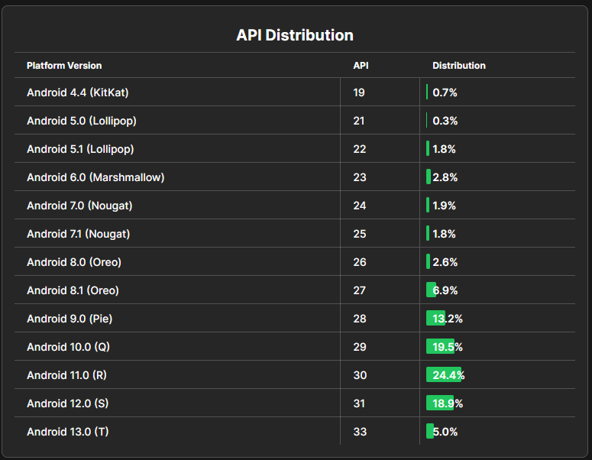

Figure 2 (Composables , 2023) Android distribution chart

This chart allows us to see that it suggests that an API level no more recent than 29 should be used. The API level of 29 encompasses 67.8% of market. 28 could be targeted which would bring the market to 81% of all handhelds. By targeting the latest API this reduces the market to 5%.

Another important aspect of creating this app is thinking about the OS features and permissions will be required. The more permissions needed will allow for richer features but some users may not want to allow permissions to certain applications such as contacts, camera, and other things that they may want to keep private. The app itself is simple so the best to generate revenue is with a simple approach. We could utilize ads by adding small adds at the footer or utilizing ads after the user records his or her weight after the 5th time recording their weight. We could also give the option to remove ads.

Composables. (2023, January 6th). *Android distribution chart*. https://www.composables.com/

tools/distribution-chart